Module 6 computational lab assignment figures

Distribution shift and single cutoff:
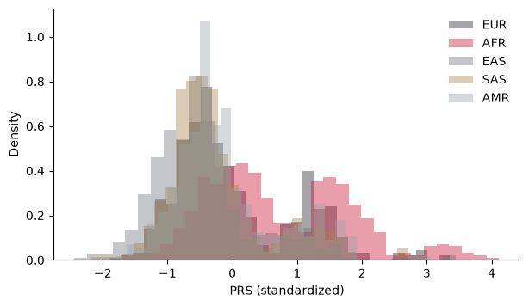
Calibration by ancestry:


